Project 1

Guess the Word

CSC-5 -45276

Name: Gonzalez, Raul

Date: 7/18/2006

**Introduction**

Title: Guess the Word

This is the guess the word code game.

The user must guess one of the top eleven most commonly used words in the English language. The user must enter the words, which increase in length. The first word to be guessed is a three character word, and then the words increase to four characters and then five.

Ex) The first word to be entered is a common three letter word like ‘you’.

The player has an unlimited amount of tries at the word in each category. When the word has been guessed in each category the game has been beat.

This game can improve grammar skills and typing skills. It will also test the user to see if she/he is familiar with the most common words.

**Summary**

Project size: 180 lines

Number of variables: 20

Number of files: 4

The project was created using concepts that were learned over the past four weeks. Many of the concepts were taken from chapters [1,7] in Starting Out with C++ 7th edition by Gaddis. This game can be improved by adding a timer so that the user will be under pressure.

In total the project took about 36 hours to complete, which includes time for brain storming ideas, and writing code as well as trouble shooting. After completing the project my understanding of the C language has improved. I understand how loops work and how files are opened and closed in a program. The IDE reads the code line by line and performs the operations.

**Description**

This program reads a string that is entered by the user and then compared to a randomly chosen word that is stored in a file.

**Flowchart**

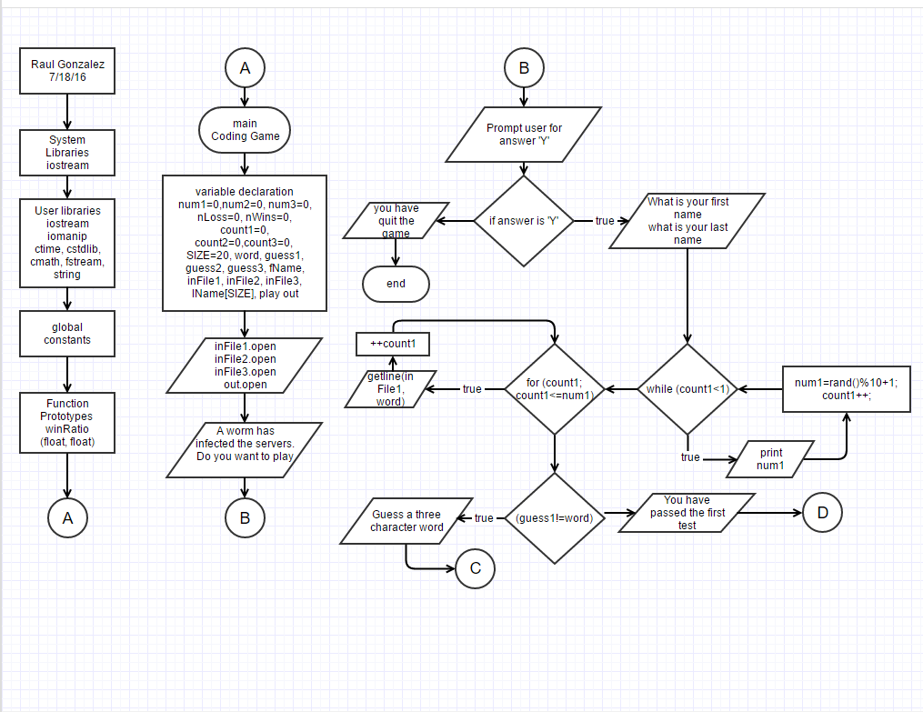

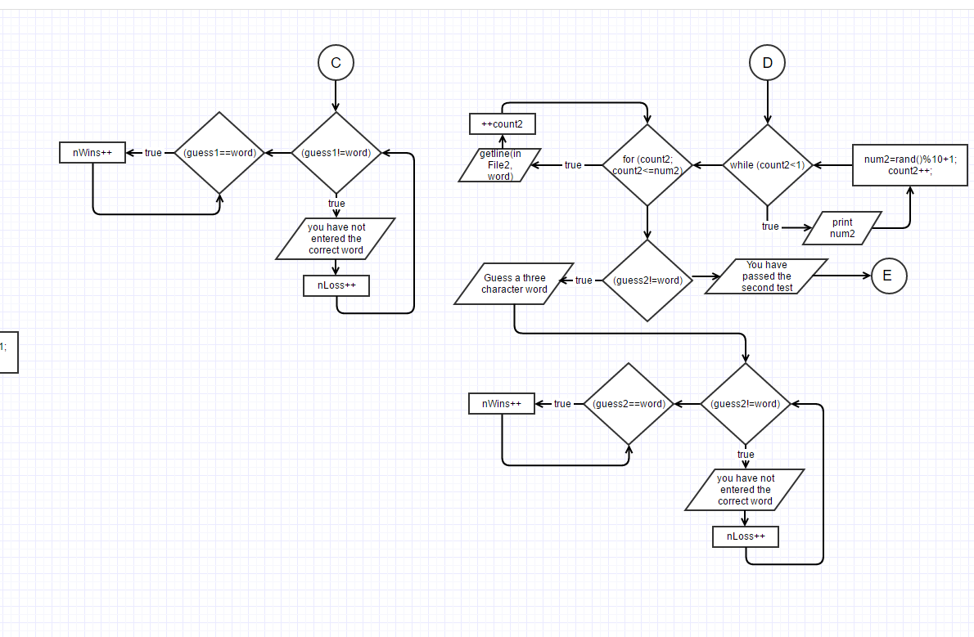

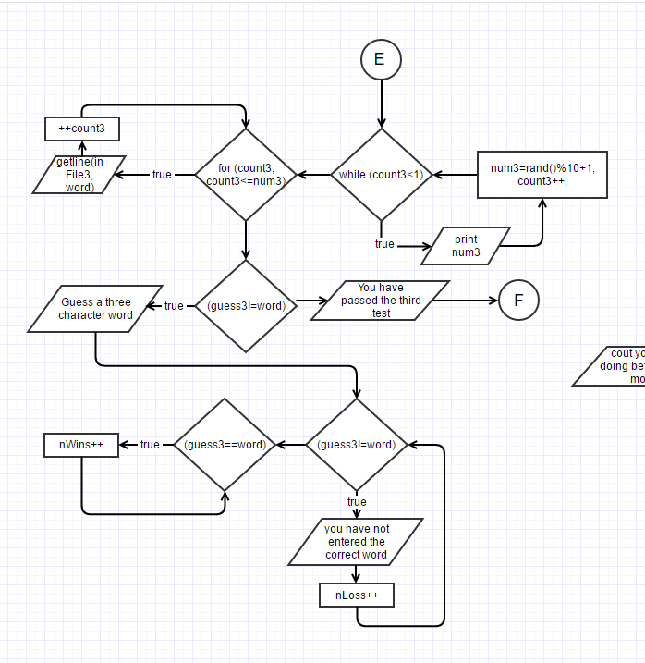

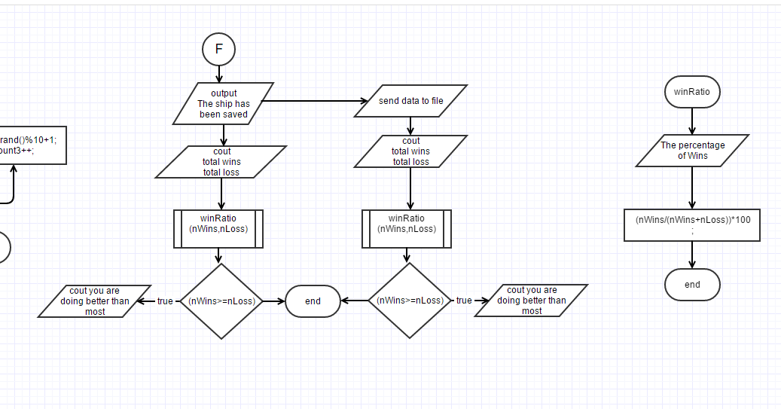

**Pseudo Code**

While guess1 is not equal to word

Guess a three character word

Compare guess with word from file

If guess is not equal to word

Increment number of losses

If guess is equal to word increment number of wins

Repeat 2X and increase size of word

Output the processed data

**Reference**

1. Gaddis Book
2. Lehr Mark github repository

**Program**

/*

* File: main.cpp

* Author: Raul Gonzalez

* Created on June 30, 2016, 1:45 PM

* Purpose: Coding Game

*/

//System Libraries

#include <iostream> //Input/Output Library

#include <ctime> //Time for random seed

#include <cstdlib> //Random number seed

#include <iomanip> //Formatting

#include <cmath> //Math Library

#include <fstream> //File I/O

#include <string> //String Object

using namespace std; //Namespace of the System Libraries

//User Libraries

//Global Constants

//Function Prototypes

float winRatio(float,float);

//Execution Begins Here!

int main(int argc, char** argv) {

//Set the random number seed

srand(static_cast<unsigned int>(time(0)));

//Declare Variables

int num1=0,num2=0,num3=0,//Random numbers used to call each word

nLoss=0,nWins=0;//Counters used for number of wins|losses

int count1=0,count2=0,count3=0;

const int SIZE=20;

string word,guess1,guess2,guess3,//Strings Declared for each guess

fName;//String used for the file

ifstream inFile1,inFile2,inFile3;//Files where words will be obtained from

char lName[SIZE],

play;//Prompts user for input to initialize the game

ofstream out;//Used to send Data to a file

//Open files and Input Data

inFile1.open("word1.txt");

inFile2.open("word2.txt");

inFile3.open("word3.txt");

out.open("stats.dat");

cout<<"A WORM has infected the servers in the Nebuchandnezzar.";

cout<<" It is up to you to save the day."<<endl;

cout<<"You must guess a series of the most commonly used words in";

cout<<" the English language."<<endl;

//Prompt User to Play

cout<<"Are you the One?"<<endl;

cout<<"Enter Y to play"<<endl;

cin>>play;

cout<<endl;

if(play=='Y'){

//Prompt user for Name

cout<<"What is your first Name"<<endl;

cin>>fName;

cout<<"What is your last Name"<<endl;

cin>>lName;

cout<<endl;

//Input the Data for the first test

while (count1<1){

num1 = rand()%10+1;

count1++;

cout<<num1<<endl;

}

for (count1 =0;count1<num1; ++count1)

{

getline(inFile1, word);//Get the word

}

//Loop used for the first guess

while(guess1!=word){

cout<<"Guess a three character word"<<endl;

cin>>setw(3)>>guess1;

cout<<endl;

if(guess1!=word){

cout<<"You have not entered the correct word"<<endl;

cout<<endl;

cout<<"Try to guess the three character word again"<<endl;

nLoss++;

}

if(guess1==word)nWins++;

}

cout<<"You have passed the first test."<<endl;

//Input Data for the Second Test

while (count2<1){

num2 = rand()%10+1;

count2++;

cout<<num2<<endl;

}

for (count2=0;count2<num2;++count2)

{

getline(inFile2, word);//Get the word

}

//Loop used for the second guess

while(guess2!=word){

cout<<"Guess a four character word"<<endl;

cin>>setw(4)>>guess2;

cout<<endl;

if(guess2!=word){

cout<<"You have not entered the correct word"<<endl;

cout<<endl;

cout<<"Try to guess the four character word again"<<endl;

cout<<endl;

nLoss++;

}

if(guess2==word)nWins++;

}

cout<<"You have passed the second test."<<endl;

//Input the data for the third test

while (count3<1){

num3 = rand()%10+1;

count3++;

cout<<num3<<endl;

}

for (count3 =0;count3<num3; ++count3)

{

getline(inFile3, word);//Get the word

}

//Loop for the third guess

while(guess3!=word){

cout<<"Guess a five character word"<<endl;

cin>>setw(5)>>guess3;

cout<<endl;

if(guess3!=word){

cout<<"You have not entered the correct word"<<endl;

cout<<endl;

cout<<"Try to guess the five character word again"<<endl;

nLoss++;

}

if(guess3==word)nWins++;

}

cout<<"You have passed the third test."<<endl;

cout<<endl;

//Output the processed Data to the screen

cout<<"The Nebuchandnezzar has been saved"<<endl;

cout<<endl;

cout<<"Total wins are "<<nWins<<endl;

cout<<endl;

cout<<"Total losses are "<<nLoss<<endl;

cout<<endl;

cout<<fixed<<setprecision(2)<<showpoint<<" = "<<winRatio(nWins,nLoss)<<"%"<<endl;

if(nWins>=nLoss){

cout<<"You are doing better than most"<<endl;

}

//Output the processed Data to a file

out<<endl<<fName<<" "<<lName<<" Game Stats "<<endl;

out<<" Number of Wins = "<<nWins<<endl;

out<<" Number of Losses = "<<nLoss<<endl;

cout<<fixed<<setprecision(2)<<showpoint<<" = "<<winRatio(nWins,nLoss)<<"%"<<endl;

if(nWins>=nLoss){

out<<"You are doing better than most"<<endl;

}

}else{

cout<<"You have quite the game with "<<play<<endl;

}

//Exit Stage Right!

inFile1.close();

inFile2.close();

inFile3.close();

out.close();

return 0;

}

float winRatio(float nWins,float nLoss){

cout<<"The percentage of Wins "<<endl;

return (nWins/(nWins+nLoss))*100;

}